QA/UAT Timeline

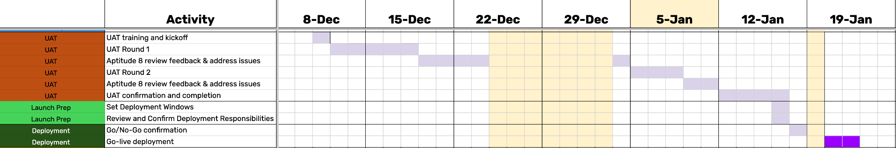

Required Testers
- Colleen
- Shaun
- Fawn
- Erin
- Britni (Optional)

Specifications for Testing Environment
- UAT will take place on Sandbox.
- Super Admin access is required. A test user is recommended that you can log into while being assigned a different permission set or team for testing in some scenarios

Resources
UAT Test Scripts
- https://docs.google.com/spreadsheets/d/1rPJAUaRP4T-wpzD3jMjS-iHpFI2hU9sfKR4lGBlAQNY/edit?gid=295013131#gid=295013131
Contact Views
- Candidate Properties
- Client Properties
Company Views
- Client Corporation Properties
Deal Views
- Opportunity Properties
- Job Order Properties
Placement Views
- Placement Properties

Defect Resolution Process
Confirm the UAT Roster. Assign each UAT scenario.
Complete the steps for each scenario.
For Task & Notification workflows, refer to this Loom using the requirement doc:
- https://www.loom.com/share/713f77d481c5444eb773abcfa9e3ebe4
- https://docs.google.com/document/d/1O4BcHDrfVRWR5czVpVTQ1i1wYPNwvunUnq27KIPkk9A/edit?tab=t.0
This links directly to our PM tool, Clickup for convenient communication and quick response.
- https://forms.clickup.com/8509516/f/83p2c-252934/XKRLEE2FCMB899H9OD

Recommendations
- When creating test records, including in the name “Test” with the UAT Test Number for easy reference
- Use BH Record ID on any HubSpot object to locate the right record in BH.
- Use Table Views above and configure and save a new custom view during your own testing, to see only the properties & records you are concerned with
- We have added BH Record ID as global searchable fields.
- It is useful to locate in HubSpot the associated object ID from Bullhorn both as confirmation that Pipedream sync has completed the association on its most recent 10 minute cycle, but also to locate the correct record in Bullhorn.
- Sandbox tends to sync on ‘the 3s’
- A test user is especially useful when configuring & testing page views. If you have a second computer logged in as the test user this process becomes more efficient.

